BERMUDA

PUBLIC ACCESS TO INFORMATION (CONTRACTS VALUED $50,000 OR MORE) (NAME OF PUBLIC AUTHORITY) NOTICE 2023

GN / 2023

The [title of head of the public authority] who has supervision of [name of the public authority], in exercise of the power conferred by section 6(6) of the Public Access to Information Act 2010, gives the following Notice:
Citation
1. This Notice may be cited as the Public Access to Information (Information Statement- Contracts Valued $50,000 or More) Bermuda Sport Anti-Doping Authority Notice 2023.

Contracts to which this Notice applies
2. This Notice applies to the contracts contained in the following Table:
Table
Name of Contractor/ Contracting Parties | Contract Start Date | Contract End Date | Description of Goods/ Services Provided | Contract Value
Woodbourne Limited | October 2021 | March 2024 | Office Rent, maintenance, and utilities. | $165,000.00

Made this 11th day Of January 2024
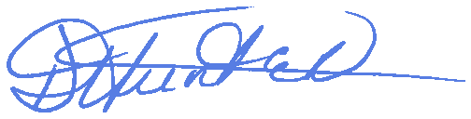
[Deborah Hunter]
The Chef Executive Officer who has supervision of the Bermuda Sport Anti-Doping Authority

